26个英文字母书写
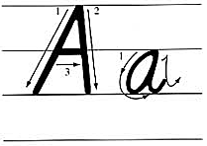 | 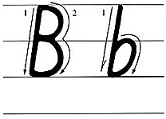 | 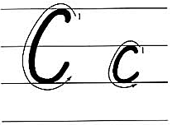 | 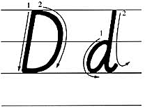
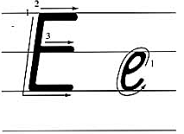 | 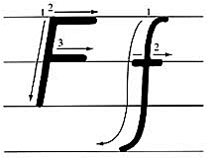 | 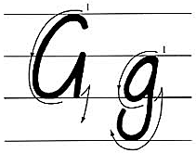 | 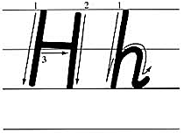
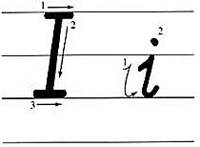 | 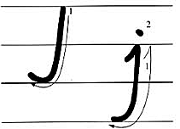 | 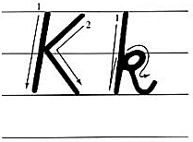 | 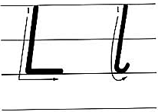
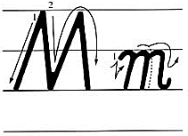 | 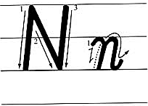 | 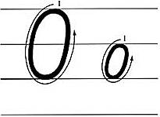 | 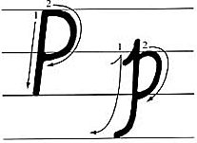
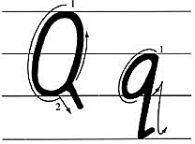 | 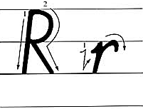 | 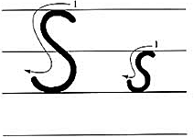 | 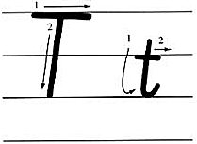
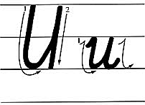 | 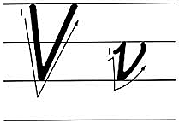 | 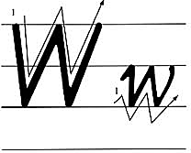 | 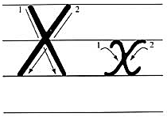
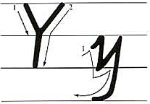 | 

    
   
   
   

   
   
   
   

   
   
   
   

   
   
   
   

   
   
   
   

   
   
   
   

   
   
   
   

   
   
   
   

   
   
   
   

   
   
   
   

   
   
   
   

   
   
   
   

   
   
   
   

   
   
   
   

   
   
   
   

   
   
   
   

   
   
   
   

   
   
   
   

   
   
   
   

   
   
   
   

   
   
   
   

   
   
   
   

   
   
   
   

   
   
   
   

   
   
   
   

   
   
   
   

